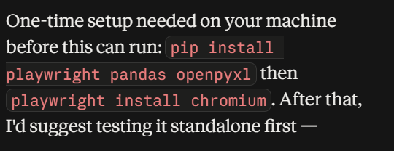

Create app password :
https://myaccount.google.com/apppasswords
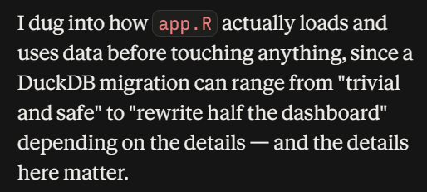

The "Unresolved Cases" analysis loops over every active reason category (up to 9) times every month in the selected window (up to 36), rebuilding a full multi-layer map plot from scratch each time — worst case over 100 full continent-scale renders in a single button click, all synchronous. "District Performance" and "SIA Scope Analysis" do the same thing on a single loop (per month, not per reason × month), so a 24-36 month window still means dozens of full map rebuilds per click. None of these results are cached, so clicking "Analyze" twice with the same filters redoes 100% of the work.
Making it worse: every one of those renders draws the full, unsimplified shapefiles (the ~9,453-row districts layer has never been simplified anywhere in the codebase), so each of those dozens-to-hundreds of renders is also doing more geometric work than it needs to. On top of that, the app actually loads its main dataset and shapefiles twice at startup, and the second, raw load silently overwrites the first, already-optimized one — meaning the memory/column-pruning optimization that's already written into the code never actually takes effect. And there's a forced garbage-collection sweep running every 30 seconds per active session, which adds its own small periodic stalls on top of everything else.

